|  |
| --- |
| **LAB 321 Assignment** |

**Type: Long Assignment**

**Code: J3.L.P0041**

**LOC: 200**

**Slot(s): 10**

**Title:** Manage Assignment

# Background

# Program Specifications

Program a web site add, view and delete assignment

**Features:**

This website contains 3 main functions

* Function 1 : Default page :

o Display list assignment contain: (PIC 01)

* + Assignment name
  + Academic Year
  + Subject
  + Allocate Date
  + Due Date

o Create Assignment: ( PIC 02)

* Data input
  + - Name (required)
    - Academic Year (required)
    - Course (required)
    - Subject(Required)
    - Allocate Date(Required)
    - Due Date (Required)
    - File upload (required)
* “Create” button click

If Assignment Name available in database, show alert or message “Assignment is existing, please input another Assignment Name”

Allocate date + Due date: Date format (Date picker) (Pic 3)

If Due Date < Allocate Date: Show error message ”Due date must be larger than allocate date”

If any required field is blank, show message “… can not be blank” (Pic 3)

If save into database successfully, show alert or message “Create success”. If Error occur show alert or message “Create fail!”

* “Cancel” button click: Do not save anything and back to “Default page”
* Function 2: View Assignment details(Pic 4)
  + Redirect to View Detail page when user click view detail button in Assignment List.

Function 3 : Delete a assignment., Delete assignment by click to **Delete** button (Pic 1), Confirm before delete (Pic 5), Show alert or message “Delete success” and reload **View Assignment List** page if delete successfully, and “Delete fail” if error occur or cannot delete.

You do not need to write interface for admin control panel, you can add data manually (use SQL SERVER Management studio).

Note: All data must be load from database, not hard code in page.

***Expectation of User interface:***

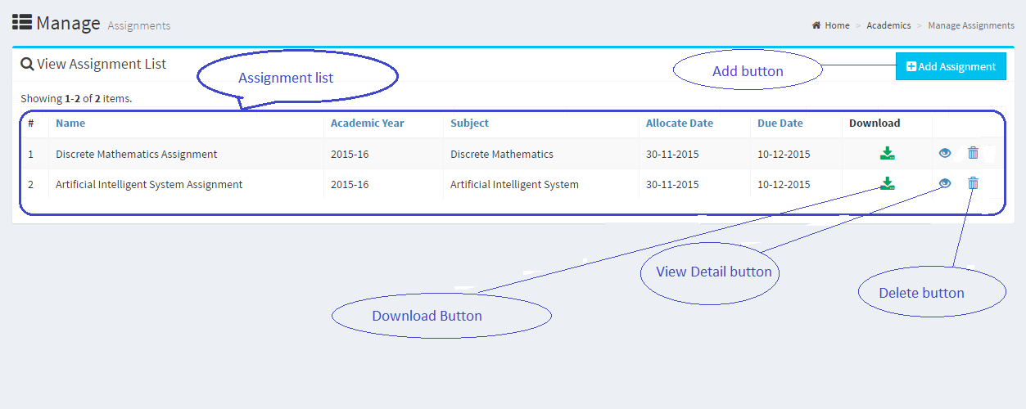

PIC 1 : Default Page

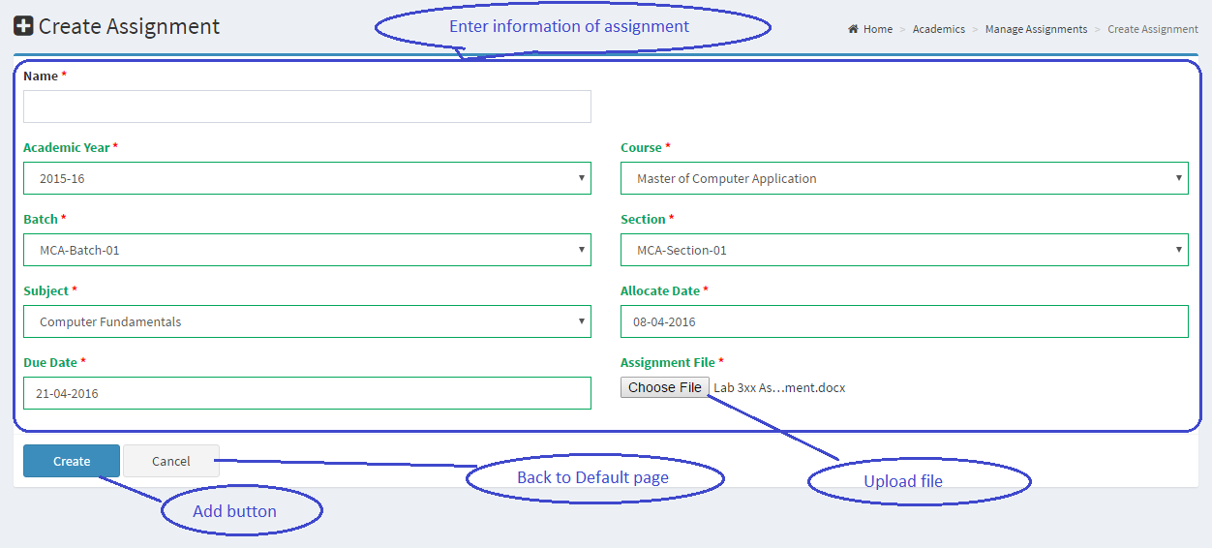

Pic 02 : Add Assignment

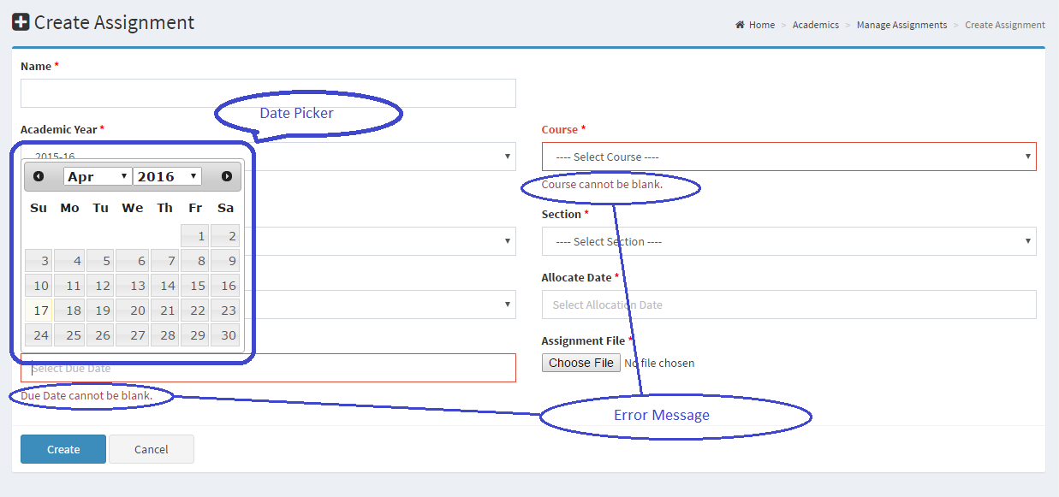

Pic 3

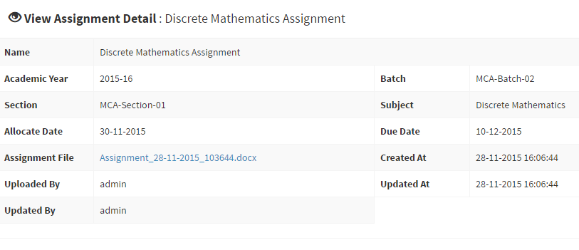

PIC 04 : View information of assignment

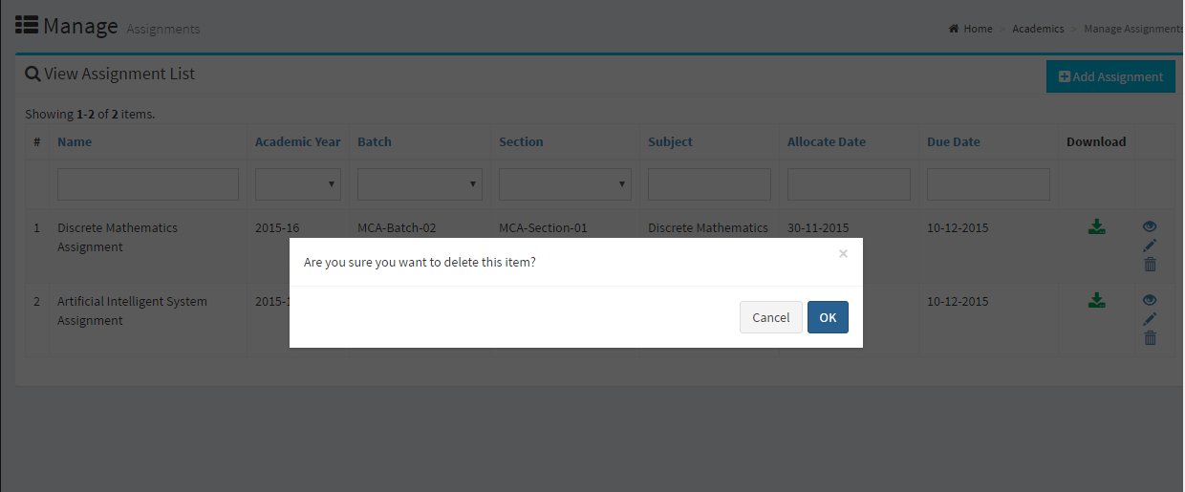

Pic 5: Confirm Dialog

# Guidelines

* Step 1 : Create web layout
* Step 2 : Create prototype
* Step 3 : Design database base on created prototype
* Step 4 : Code & Test